Suns Report

4th Grade – Mrs. Johnson– Room 18

August 1st – 5th

This is what we will be working on this week:

**Our Learning Goals This Week:**

ELA (English Language Arts):

I can determine the central idea of a text and relevant supporting details.

Math:

I can compare, order, and round multi-digit numbers up to 1,000,000 using my understanding of place value.

Specials Schedule:

Monday - Library

Tuesday - Music

Wednesday – PE

Thursday – LAB

Friday - Music

*Please make sure that your child brings a water bottle and comes with tennis shoes on days we have P.E.*

***Upcoming Dates***

**Curriculum Night**

Wednesday, August 3rd

5:00 – 6:00 PM

*Rm. 13 for ALL 4th Grade classes

**CEF Cash For Classrooms**

**Monday, August 15th - 19th**

*\*This is a fundraiser to support the Chandler Education Foundation Scholarship Program*

Eat Out at MOD Pizza

**Wednesday, August 24th**

**Cooper & Warner – 10:30am – 10:00 pm**

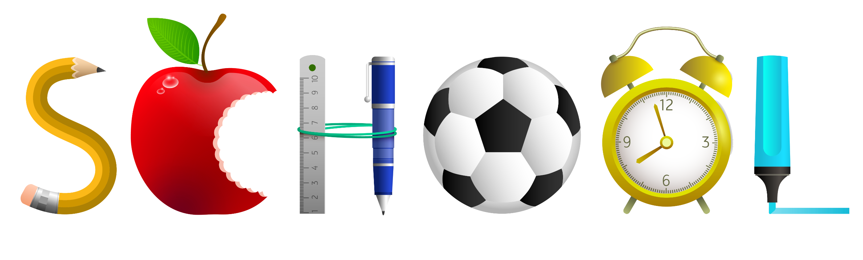

**Reminders:**

Dear Parents,

What a great first few days back to school we have had! Our students are already working hard and getting back into the swing of things.

This coming Wednesday, Aug. 3rd please join us for our Sanborn Curriculum Night.

There will be two sessions:

5:20 - 5:40 pm.

5:40 – 6:00 pm.

All 4th grade classes will meet in Rm. 13 for this event.

Additionally, we have sent home with your child an Elementary Handbook Signature page. Go to [www.cusd80.com/elementaryhandbooks](http://www.cusd80.com/elementaryhandbooks) to find the handbook and read it with your child. Please sign and return this “pink” form by or before August 5, 2022.

Finally, a big thank you to all of our families that sent in classroom supplies! We greatly appreciate your support.

4th Grade Team